Running Python3 From Terminal and pass Command Line arguments in Terminal (using VS Code)

For Assignment 2: “DB Part 1: Data at Your Command”, you will need to run Python3 from the command line and pass in command line arguments. The easiest way to do this is to run Python3 from “Terminal”. This document goes through how to do that from VS Code

1. Step 1: Open up VS Code and go to Terminal on the top 🡪 “New Terminal”. That should open up Terminal on the bottom of the screen

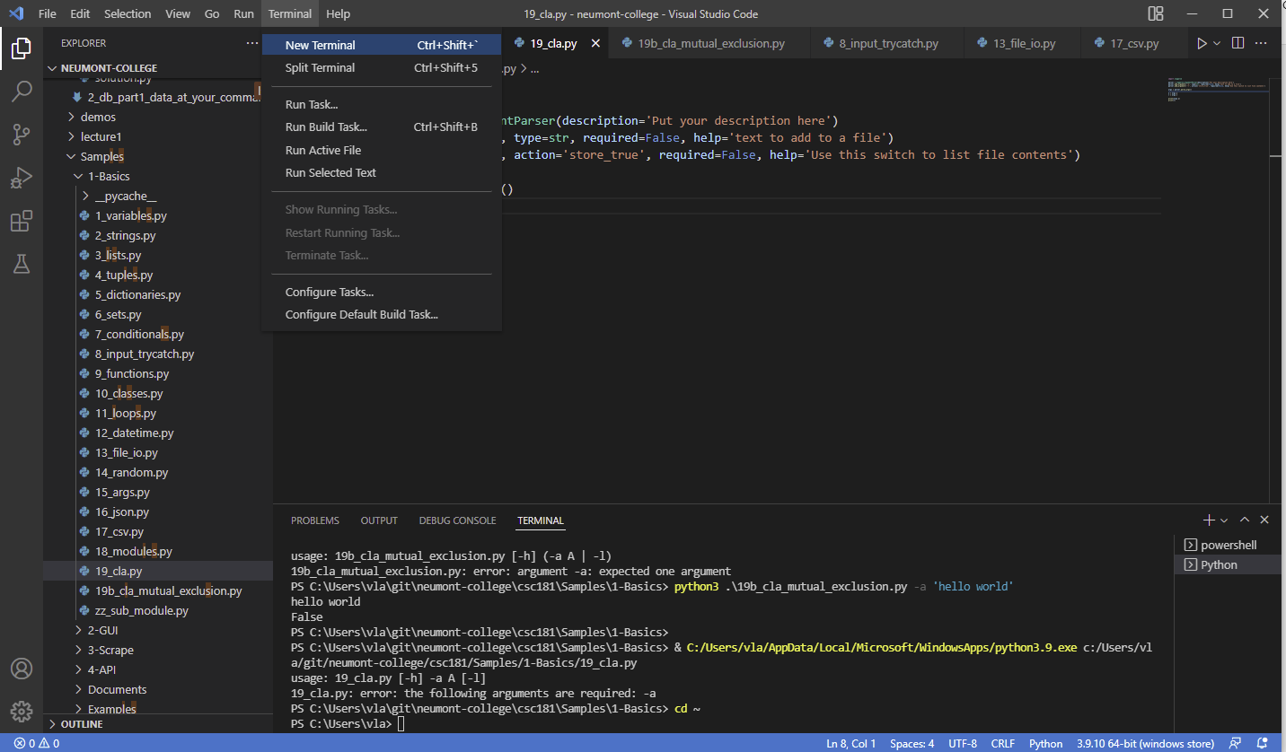

1. Step 2: Click “Run” on the top right, you will then see the file path in the terminal screen at the bottom of the screen

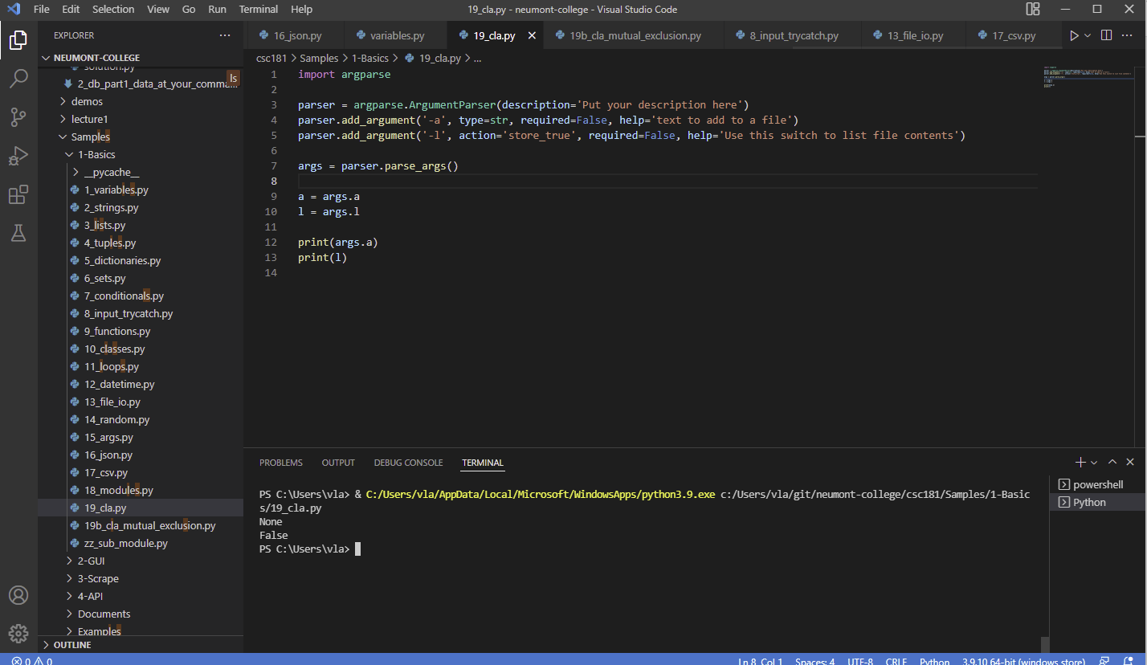



1. Step 3: cd (Change directory) to the file path as shown at the bottom of the terminal. In my case, it’s going to be “cd c:/Users/vla/git/neumont-college/csc181/Samples/1-Basics”
2. Step 4: Then you can run the python file from terminal and pass in command line arguments. For example, in my case it’s python3 19_cla.py -a “Hello world”